DAY 10 - 20.6.25
Python Coding Task

Q1. Understanding Access Specifiers
Create a class `Student` with the following properties:
Class Requirements:
1. `name` → Public attribute
2. `_roll_number` → Protected attribute
3. `__marks` → Private attribute
Implement the following methods:
- Constructor to initialize all attributes.
- `display_details()` → Public method to display all attribute values.
- `_update_roll_number(new_roll)` → Protected method to update roll number.
- `__update_marks(new_marks)` → Private method to update marks.
- `access_private_method(new_marks)` → Public method that uses the private method `__update_marks`.
ANSWER
class Student:
def __init__(self, name, roll_number, marks):
self.name = name
self._roll_number = roll_number
self.__marks = marks
def display_details(self):
print(f"Name: {self.name}")
print(f"Roll Number: {self._roll_number}")
print(f"Marks: {self.__marks}")
def _update_roll_number(self, new_roll):
self._roll_number = new_roll
print(f"Roll number updated to: {self._roll_number}")
def __update_marks(self, new_marks):
self.__marks = new_marks
print(f"Marks updated to: {self.__marks}")
def access_private_method(self, new_marks):
self.__update_marks(new_marks)

Q2. Demonstrate Access
In the main section:
- Create an object of the `Student` class.
- Modify and print the `name` directly.
- Modify and print the `_roll_number` directly.
- Try accessing `__marks` directly and observe the result.
ANSWER
student1 = Student("Amar", 101, 88)
student1.name = "Amari"
print(f"Modified Name: {student1.name}")
student1._roll_number = 202
print(f"Modified Roll Number: {student1._roll_number}")
try:
print(student1.__marks)
except AttributeError as e:
print(f"Error accessing __marks directly: {e}")

Q3. Inheritance and Access Control
Create a subclass `Topper` that inherits from `Student` and includes:
- A method `try_access()` that attempts to access `_roll_number` and `__marks` from the subclass.
- Show what works and what doesn't.
ANSWERS
class Topper(Student):
def try_access(self):
print(f"Accessing protected _roll_number from subclass: {self._roll_number}")
try:
print(f"Trying to access private __marks: {self.__marks}")
except AttributeError as e:
print(f"Cannot access __marks from subclass: {e}")

Q4. Use of Name Mangling
Demonstrate how to access the private attribute `__marks` using name mangling technique from outside the class.
ANSWERS
print(f"Accessing __marks via name mangling: {student1._Student__marks}")

Q5. Reflection
Answer the following short questions:
1. Why can’t private members be accessed directly?
Ans: Because they’re meant to be hidden. Python changes their name in the background (called name mangling) so that they don’t get messed with by accident. It’s a way to keep the data safe inside the class.
2. What is the purpose of using protected members in class design?
Ans : Protected members are kind of a “warning” to other programmers. It says: “You can use this, but you probably shouldn’t unless you’re inside this class or a class that inherits from it.” It helps keep the code cleaner and more organized.
3. How does name mangling help with private members in Python?
Ans:It changes the name of private variables behind the scenes. For example, __marks becomes _Student__marks. This doesn’t make it impossible to access, but it makes it harder, so people don’t accidentally use or change them.

Python Question Paper : Task 2

Section A: Basic File Operations (Q1 - Q3)
Q1. Write a Python program to create a text file named `sample.txt`, write your name and a message into it, and then close the file.
with open("sample.txt", "w") as f:
f.write("YourName\n")
f.write("This is a message written to the file.\n")
Output :
Q2. Write a program to read and display the contents of `sample.txt`.
with open("sample.txt", "r") as f:
content = f.read()
print("File content:\n", content)
Output :
Q3. Write a Python script to append a new line `"This is an appended line"` to `sample.txt` and display the updated content.
with open("sample.txt", "a") as f:
f.write("This is an appended line.\n")

with open("sample.txt", "r") as f:
content = f.read()
print("Updated content:\n", content)
Output : 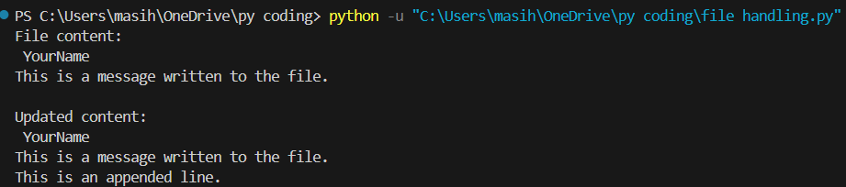

Section B: File Processing and Analysis (Q4 - Q7)
Q4. Write a Python program to count the total number of lines in a given file `sample.txt`.
with open("sample.txt", "r") as f:
lines = f.readlines()
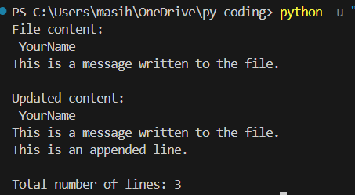
print("Total number of lines:", len(lines))
Output :

Q5. Write a Python program that reads a file and prints only those lines that contain the word “Python” (case-sensitive).
with open("sample.txt", "a") as f:
f.write("I am learning Python.\n")
f.write("Python is fun!\n")
print("\n Lines containing 'Python':")
with open("sample.txt", "r") as f:
for line in f:
if "Python" in line:
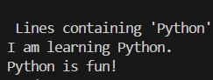
print(line.strip())
Output :

Q6. Write a Python program to count the number of words and characters in the file `sample.txt`.
with open("sample.txt", "r") as f:
text = f.read()
words = text.split()
print("Word count:", len(words))
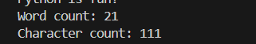
print("Character count:", len(text))
Output :
Q7. Write a program to copy the contents of `sample.txt` to another file `copy_sample.txt`.
with open("sample.txt", "r") as source, open("copy_sample.txt", "w") as destination:
destination.write(source.read())
print("Contents copied to 'copy_sample.txt'")
Output : 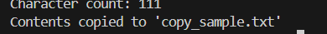

Section C: Advanced File Handling (Q8 - Q10)
Q8. Write a Python program to display the last 3 lines of a text file.
with open("sample.txt", "r") as f:
lines = f.readlines()
print("Last 3 lines of the file:")
for line in lines[-3:]:
print(line.strip())
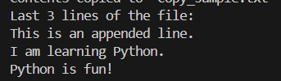

Output

Q9. Write a Python program that reads numbers from a file `numbers.txt`, one per line, and with open("numbers.txt", "w") as f:
f.write("5\n12\n9\n22\n33\n40\n")
with open("numbers.txt", "r") as infile:
with open("even_numbers.txt", "w") as outfile:
for line in infile:
number = line.strip()
if number.isdigit():
if int(number) % 2 == 0:
outfile.write(number + "\n")
Output : 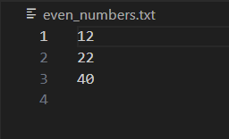
Q10. Create a program that accepts user input (name, age, city) and stores it in a CSV file `users.csv`. Ensure that every new entry is stored on a new line.
import csv
name = input("Enter your name: ")
age = input("Enter your age: ")
city = input("Enter your city: ")
with open("users.csv", "a", newline='') as f:
writer = csv.writer(f)
writer.writerow([name, age, city])
print("User data saved to 'users.csv'")
Output : 